To complete multiple pumps in AFT – Fathom, the following describes how the model will need to be built to keep the pump selection simple and work within constraints of 12 segments of pipe.

The model will need to be built into separate models as in the example shown below:

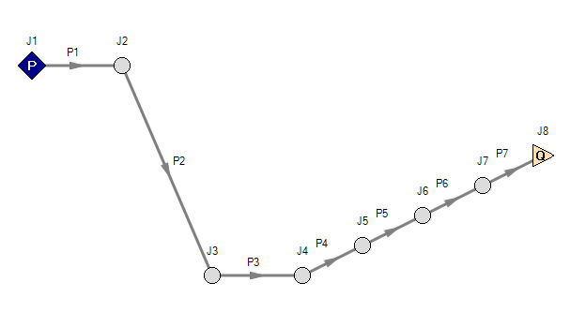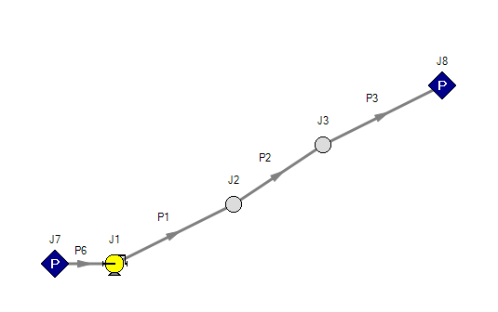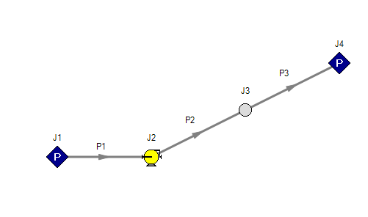



Location of Q for Example only, can be located at any “Branch” location

Flow Rate Calculated for ZBE change

Pressure = 100 psig

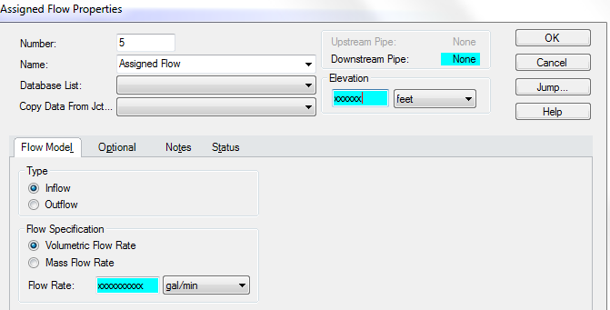

Flow Rate Calculated for ZBE change

Elevation for Selected Location



1 foot long pipe (don’t account for in cost estimating )

Choose Point for 2nd pump and guess pressure;

Insert Pump per previous directions

Use output pressure from previous model

Outlet Pressure = 50 psig



1 foot long pipe (don’t account for in cost estimating )

Insert Pump per previous directions

Use output pressure from previous model

**Things to check:**

1. **Flow rates are matching between models**
2. **Elevation profile and distances match Table 7 (can be confusing between multiple models)**
3. **Velocity is between 2 ft/s and 8 ft/s**
4. **Verify NPSHA in analysis is larger than the pump requirement**
   1. **To convert from PSIG at the transition between models to NPSHA, take pressure and divide by 0.433 to verify pump acceptability**
5. **Verify horsepower requirement versus pump capability**
6. **Adjust pump locations based on best solution for reducing pressures in the line and resultantly keeping the Wall Thickness of the pipe as minimal as possible**